CSC2521 - Assignment 2

Ziheng Liang

1000393059

Image

Default Setting:

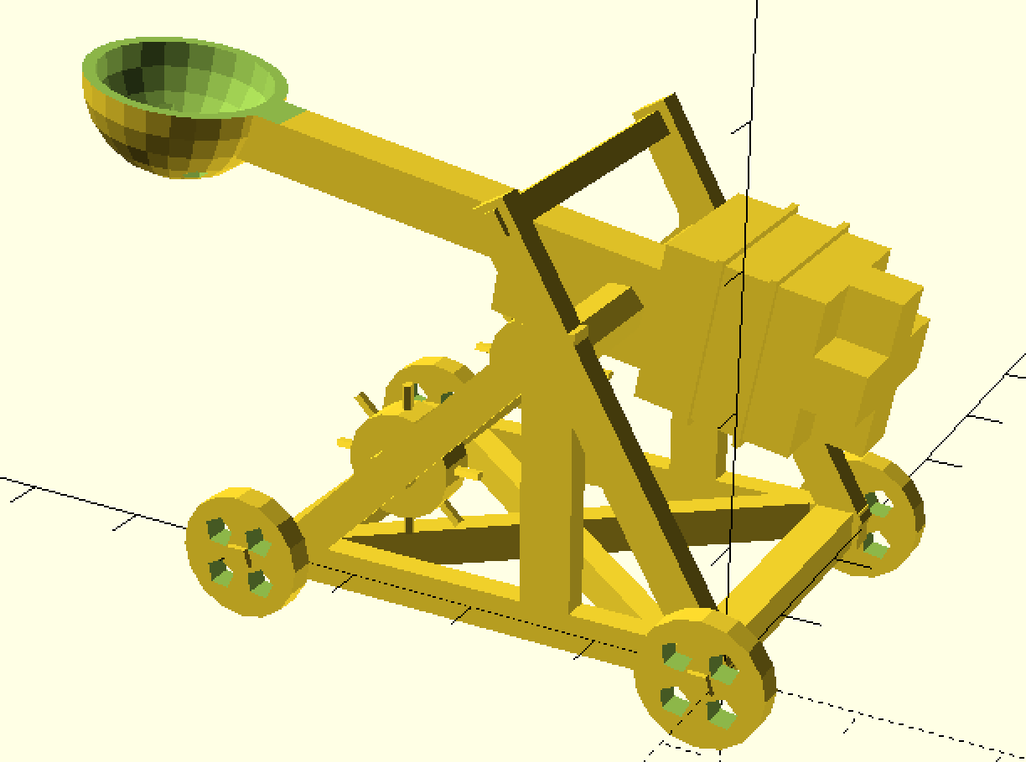

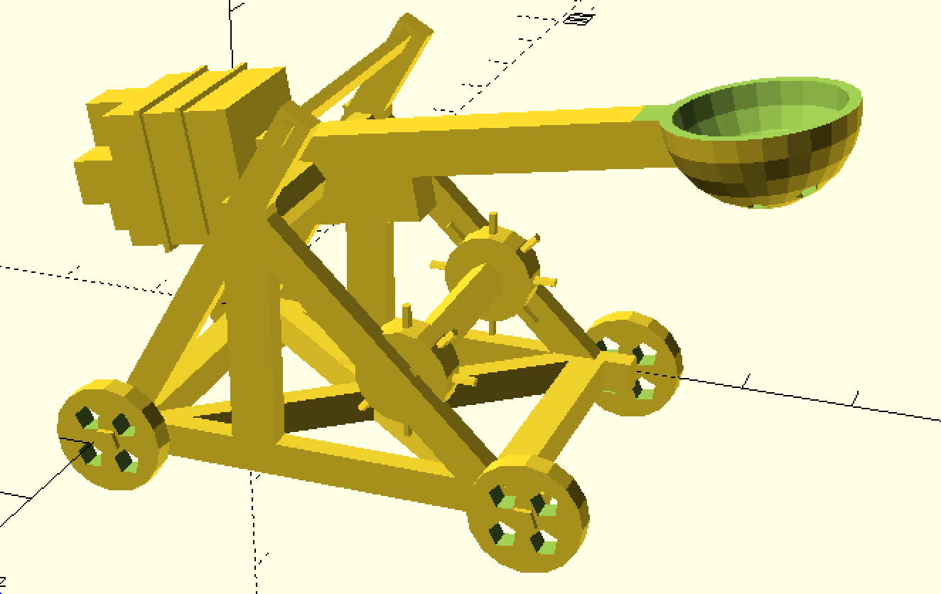

Image of changing various parameter:

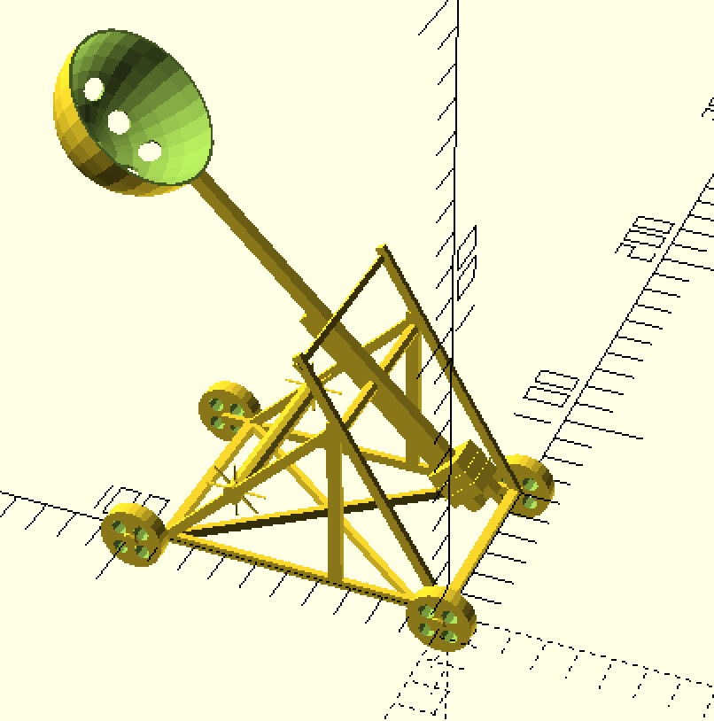

Parameters:

width,length

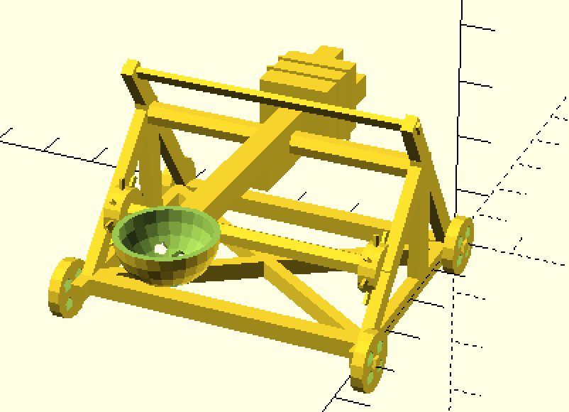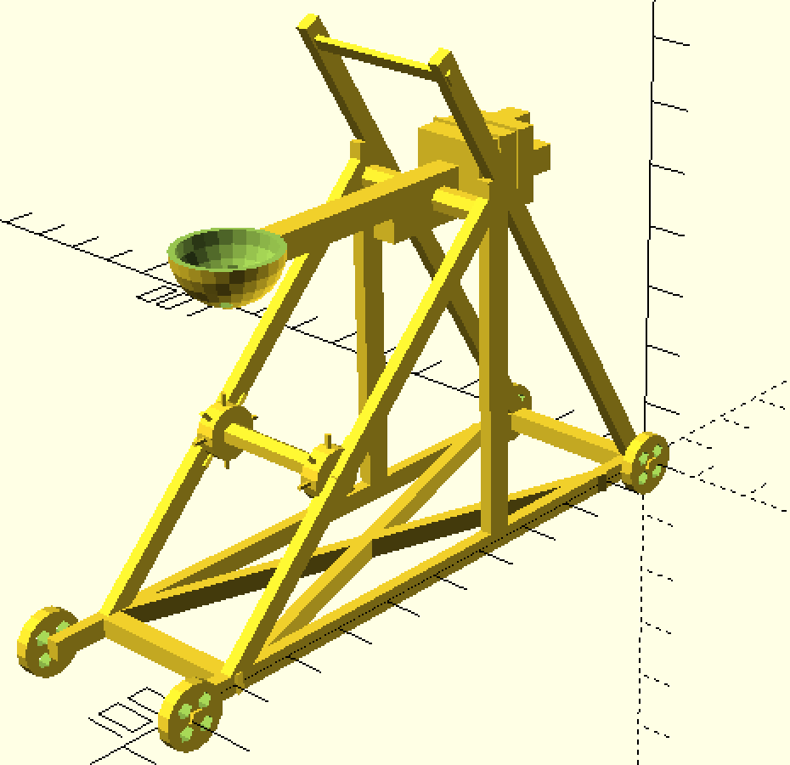

This two-variable control the overall size of the basic frame. There is not hard limit to these variables. But it’s reasonable to keep width and length within a range and not too small. The default value is width=26 length=40.

wheel_r, wheel_h

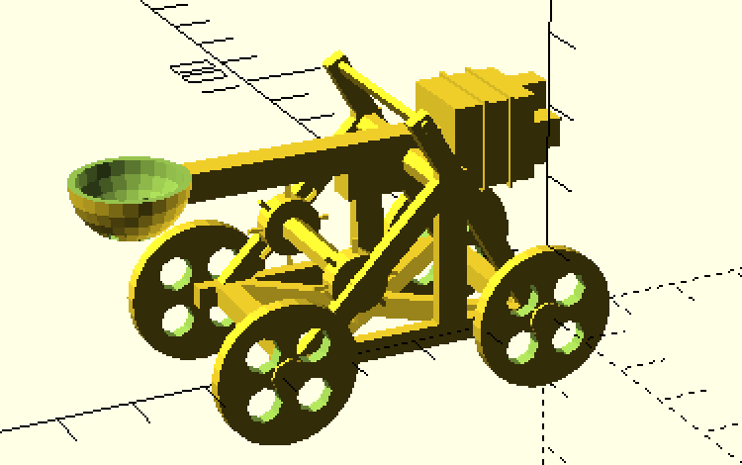 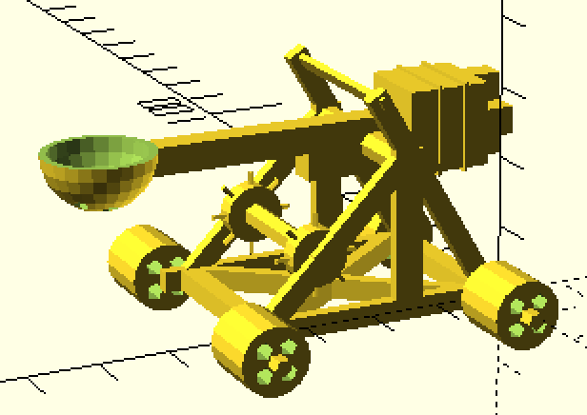

These two variables control the radius and height of the wheels. Default value is wheel_r=5 wheel_h=2.

arm_angle, arm_size

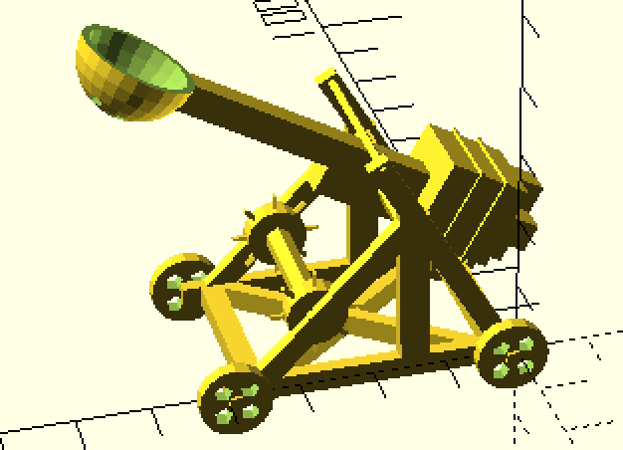 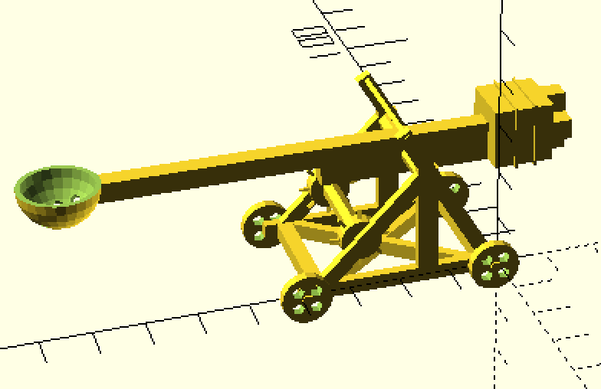

These two variables control the angle of the arm and the length of the arm. Generally the angle can be in [-20, 40]. But the lower bound is in inverse relationship with arm length. Arm length can be antyhing greater than 60. Value below that will cause the bucket and weight crush into each other. Default value is arm_angle=0 arm_size=60.

gear_handle_length,gear_h,gear_r, gear_connector_r

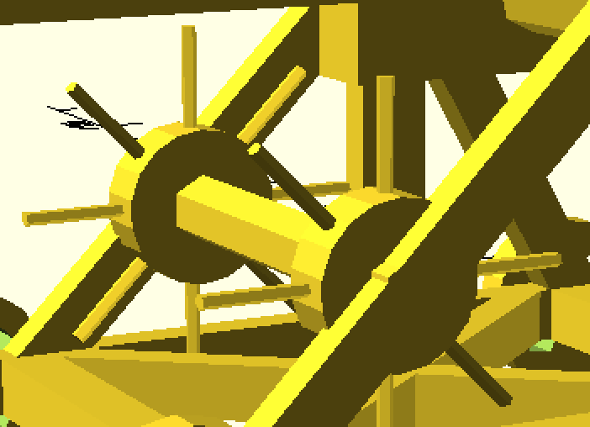 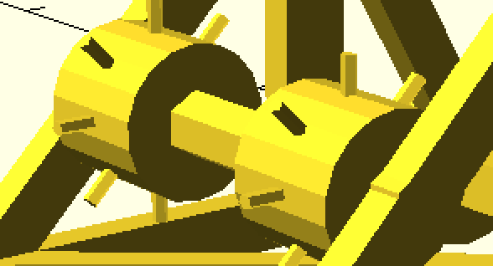

 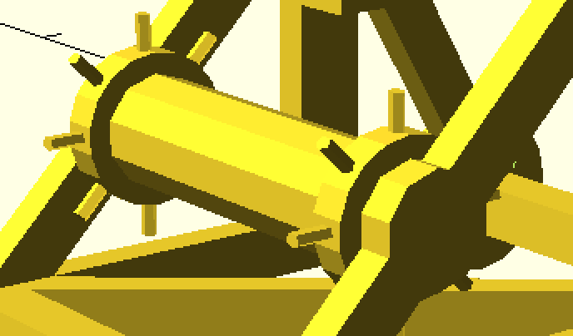

These four variables control the shape of the gear at the bottom. Generally, handle length need to be at least 100% more than the gear’s radius to be seen. Gear’s radius need to be larger than gear connector’s radius. Default value gear_handle_length=16 gear_h=2 gear_r=5.5, gear_connector_r=3.

b_r

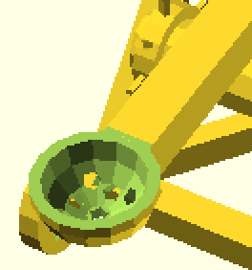 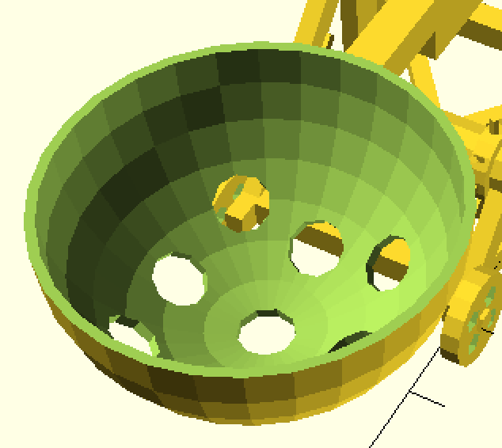

This variable controll the size of the bucket. Default is 8;

Structure:

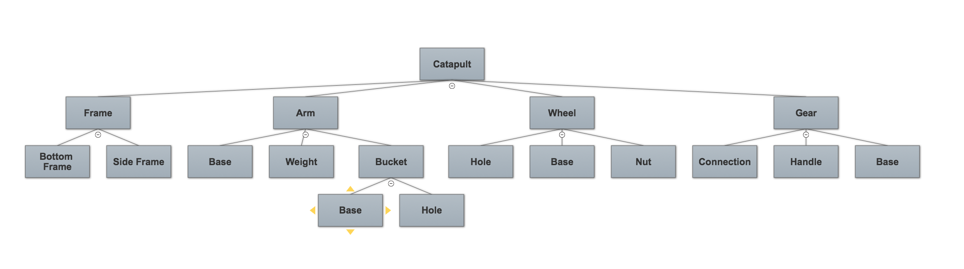

Reference:

For this assignment, I mainly use the cheat sheet provided in the assignment document.

Problem:

Some joints are not connected perfectly. For example, when the length is too large, the sticks at the side might be disconnected. This can be fixed by using difference() function where you subtract the triangle in the middle instead of union of couple sticks.